Author: Mark Kingswood
Published: August 2022
Final Version

Curriculum planning audit tool for Primary phase MFL leads
Planning an engaging curriculum which leads to both enjoyment and great progress is a challenging task, even when dealing in a subject area with which you are familiar or have a high degree of expertise.
Attempting this task in MFL, when in many cases the subject lead may have very little knowledge of the language in question or of MFL pedagogy, can be extremely daunting.
From my visits to schools, it seems to often be the case that there is an inherited scheme of work, with which the MFL lead is satisfied up to a point but which they would like to develop further over time.
I have conducted several visits to schools where I have looked with them at their current lessons and schemes and engaged in a collaborative process of long and medium-term planning. Over time, the intention is to bring this work to bear more widely with the Primary MFL community, with the aim of developing a consistency of approach which will make my own network and CPD offer of increasing relevance and use to Primary practitioners across Hampshire and the Isle of Wight.
In the meantime, I suggest that colleagues wishing to evaluate and adapt their current offer, adopt simultaneously two trains of thought – what do we do well now that we want to keep and evolve and what do we need to change/develop?
With this in mind I have created the curriculum audit diagram below, which I hope will be of assistance. My belief is that it encourages reflection in a methodical and chronological way, of the key features of an effective curriculum.
As always, I am more than open to feedback and to working with colleagues on the development of their own curriculum and look forward toworking with as many of you as possible.
Mark Kingswood
Secondary Inspector/Adviser and MFL Lead

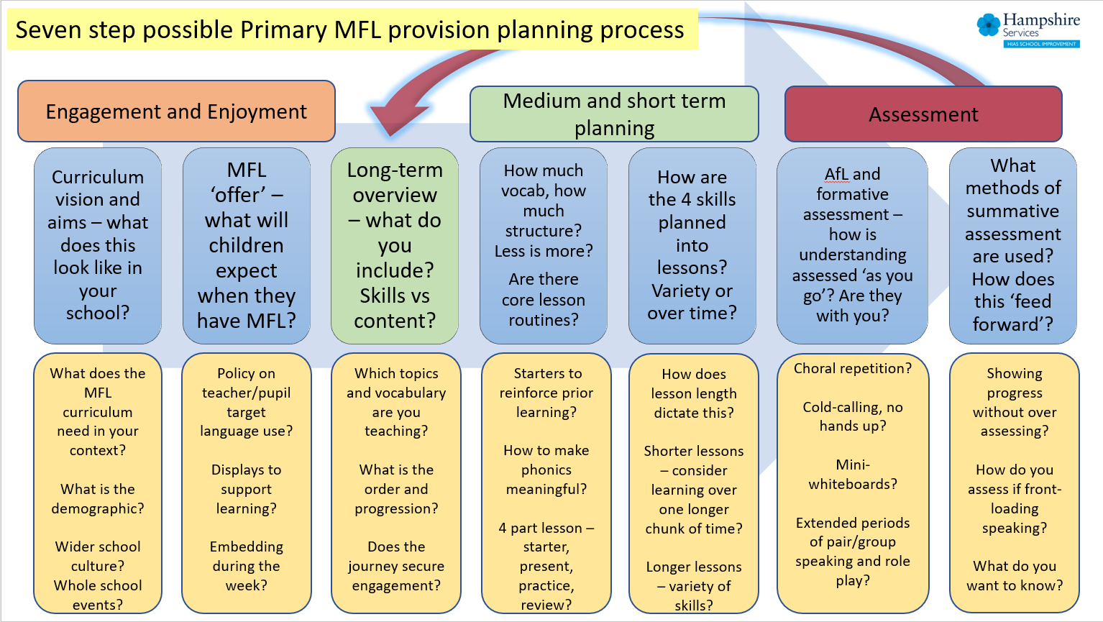

Mark Kingswood
Secondary Adviser/Inspector and Subject lead for MFL
Hampshire Inspection and Advisory Service
Children’s Services Department, Block E, Clarendon House,
Monarch Way, Winchester. SO22 5PW
Tel: 03707 794112
Mob: 07488 317998
Email:mark.kingswood@hants.gov.uk
For further details on the full range of services available please contact us using the following email:
htlcdev@hants.gov.uk
Upcoming Courses
Keep up-to-date with our learning opportunities for each subject through our Upcoming Course pages linked below. To browse the full catalogue of learning offers, visit our new Learning Zone. Full details of how to access the site to make a booking are provided here.
- English
- Maths
- Science
- Geography
- RE
- History
- Leadership
- Computing
- Art
- D&T
- Assessment
- Support Staff
- SEN

